COURSE: VDIT Diploma in IT
UNIT OF STUDY: VIT1202 Operating Systems ASSESSMENT TITLE: Practical Assignment – Part B ASSESSMENT TYPE: Assignment
Student name: Aleksandar Ivanov Student ID: s8090291

Instructions:
- Enter your Name and Student ID above.
- This assessment needs to be completed individually.
- You need to install a virtual server and client to complete the tasks and to record evidence.
- Make sure to save this document progressively as you work through the assessment.
- Refer to the rubric provided detailing all tasks to be completed and how marks are assigned.
- Plagiarism will not be tolerated. Copied work for practical assignment can easily be detected.
Mark breakdown
- Weighting: This assessment is worth 20% of your final result for this unit of study

Conditions
- This assessment is Open Book. You are free to use any resources or materials on VU Collaborate and any of your own summary notes.
- Duration is 90 minutes.
- You will be required to provide evidence of your solution in the form of screen captures and answers to questions on this assessment. Your final submission will consist of this assessment document containing the required screen captures.
- You may be required to demonstrate your solution to your teacher prior to submission of this assessment document. Your teacher will ask you to run some diagnostic commands to assess your solution.
Resources
- Classroom PCs with Virtual Box Software installed
- Two Virtual Machine (OVA) files: Oracle Linux 9 – Server1.ova, Oracle Linux 9 – Client1.ova
- The OVA files will be provided by your teacher:
  - A link will be provided to download the files
- A screen capture program e.g. Snipping Tool
- Use the last 2 digits of your Student ID for the value of x in the IP addressing Scheme.

Description of Tasks

In this assessment you will build a peer to peer network between two Linux machines. A Linux server deployed as a NFS and HTTP Server, a Linux client deployed as a NFS and HTTP Client.
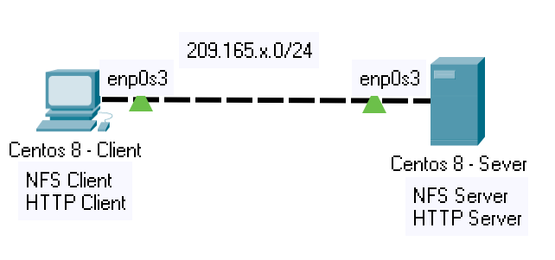

209.165.x.0/24

Task 1 - Virtual Machine Installation
- You will be provided access to two Linux Oracle Linux 9 Virtual Machines (OVA) files that can be imported into Virtual Box.
- Make sure to select Generate new MAC addresses during the import process and change the Network settings in Virtual Box to Internal Network for these machines before starting them.
- Install the required packages for each machine (may have been preinstalled):
  - Server Machine (nano, httpd, tree, nfs-utils, rpc-bind)
  - Client Machine (nano, tree, nfs-utils).

Task 2 - Peer to Peer Networking:
- Configure networking for both systems according to the following IP address scheme:

Machine | Interface | IP Address | Netmask | Gateway | DNS
Oracle Linux 9 Server1 | enp0s3 | 209.165.91.1 | 255.255.255.0 | 209.165.91.254 | 209.165.91.1
Oracle Linux 9 Client 1 | enp0s3 | 209.165.91.2 | 255.255.255.0 | 209.165.91.254 | 209.165.91.1

- Run the command ifconfig | head to display the IP address information for the machines. Capture the outputs for both machines and paste it here:
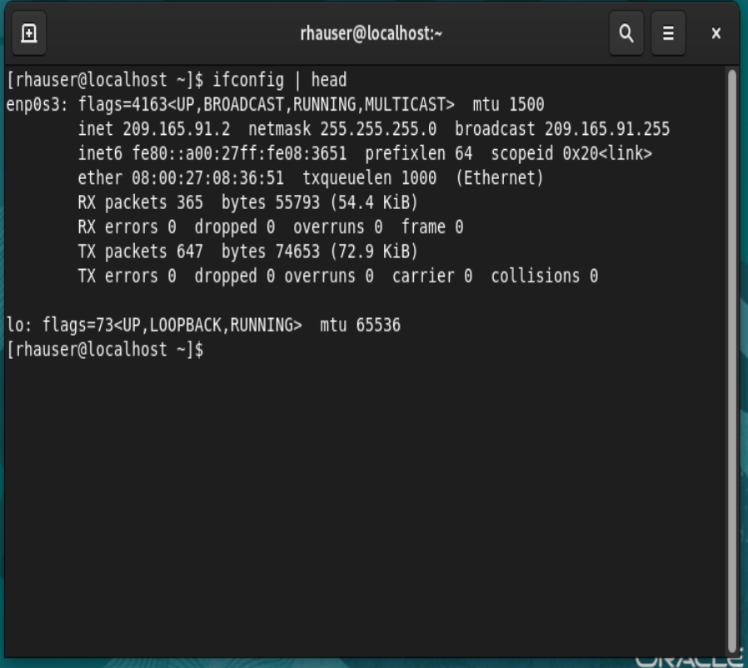
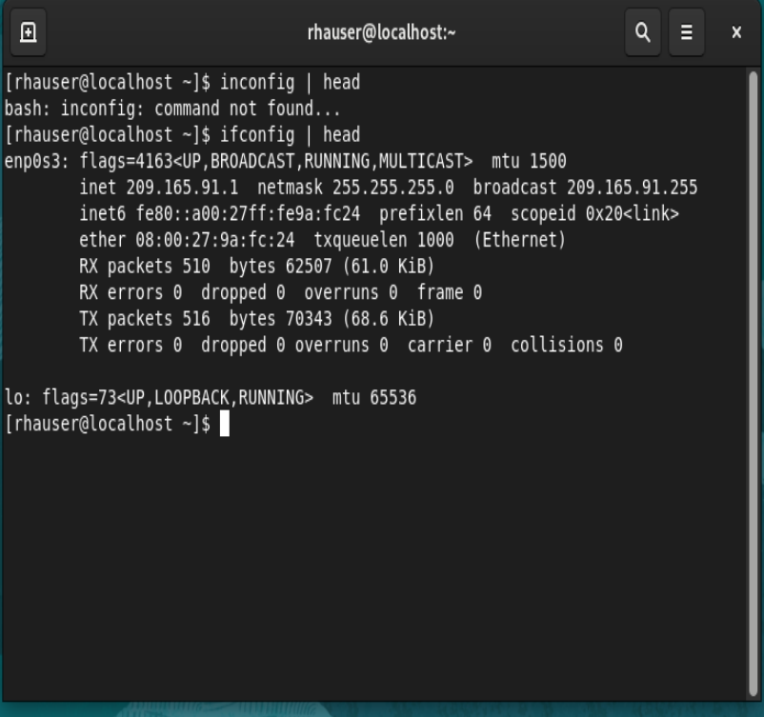

- Ping from the NFS-Client machine to the NFS-Server to verify peer connectivity. Capture the screen and paste in the answer section provided: (Use ping –c 4 <ip address>)

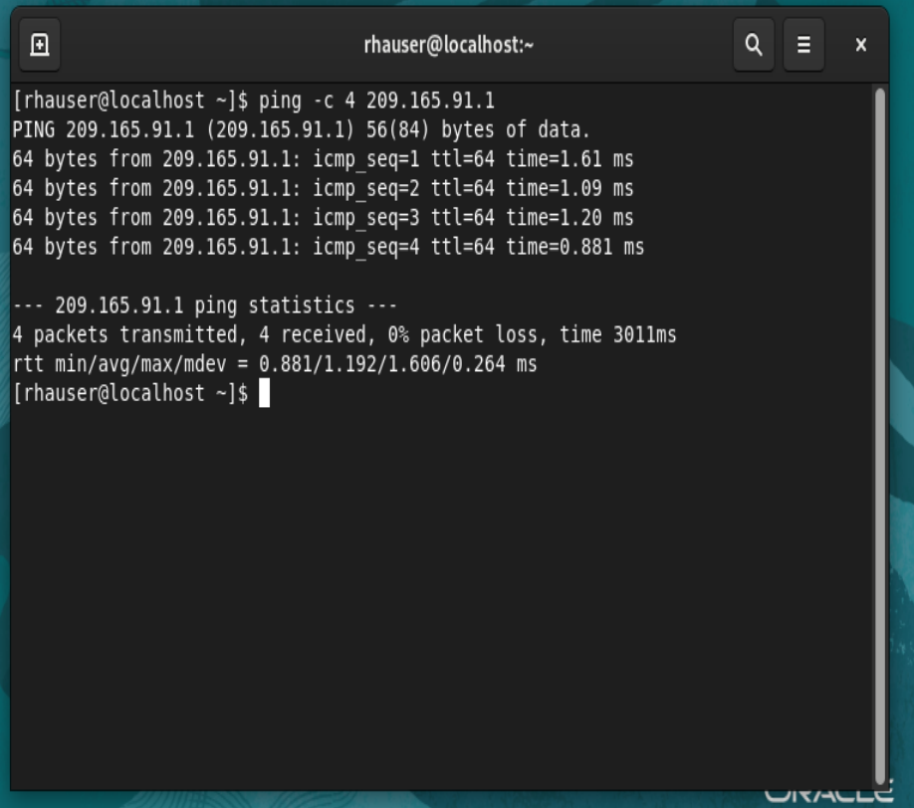

You are required to setup a NFS share on the NFS Server to be accessed by the NFS Client. The shared folder will provide read/write access to any files created in this shared space. Both NFS Server and Client are able to create/edit any files where changes can be seen from both sides.

Task 3 – Configure NFS Server
Configure NFS server on the server system to export the /mnt/nfs-server/share folder to all clients on the network above via NFS. Run the following command: sudo systemctl status nfs-server, take a screenshot of the terminal output and paste it here:
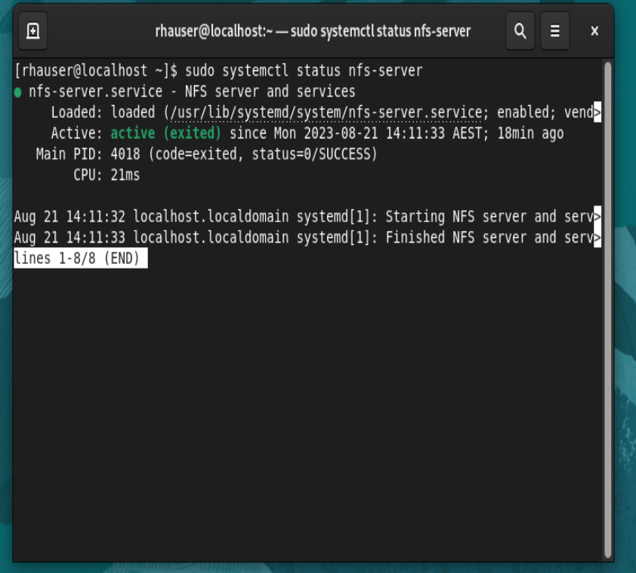

- NFS clients should have read/write access to the shared folder.
- Add a file named file1.txt with some content to the shared folder.
- Open the required ports on the firewall-serserver
- Run the following commands:
sudo tree /mnt
sudo ls -lR /mnt
Take a screenshot of the terminal output and paste it here:
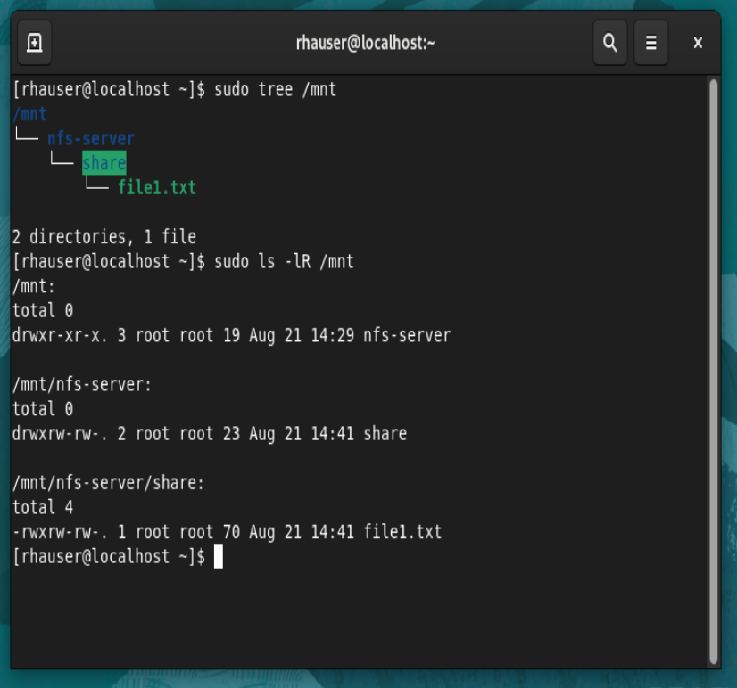

Run following command: sudo exportfs –s, take a screenshot of the terminal output and paste it here:
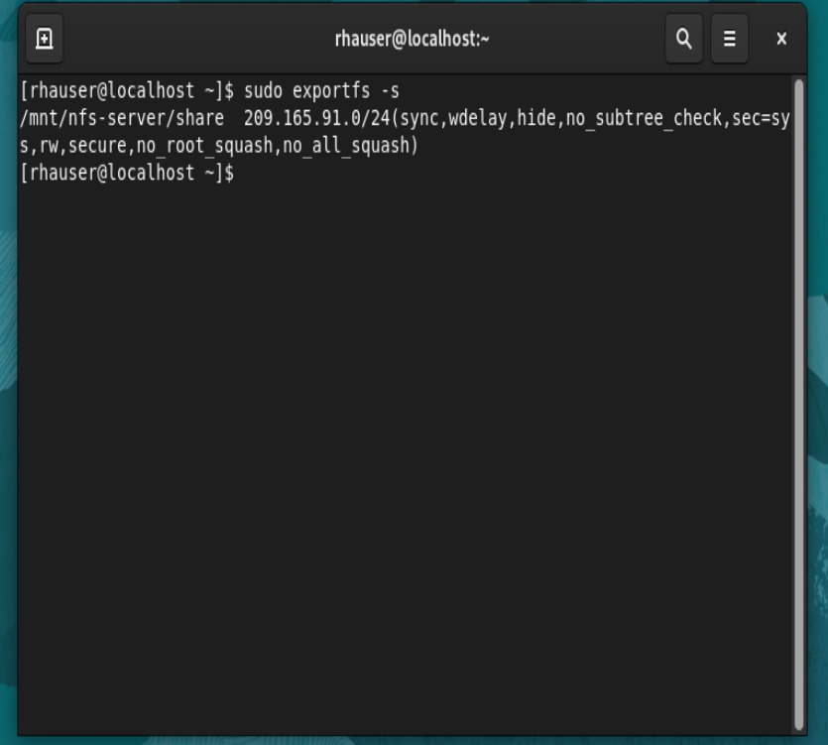

On your NFS Server, run the command: sudo firewall-cmd --list-all to display all the ports open in the Firewall. Take a screenshot of the terminal output and paste it here:

/mn20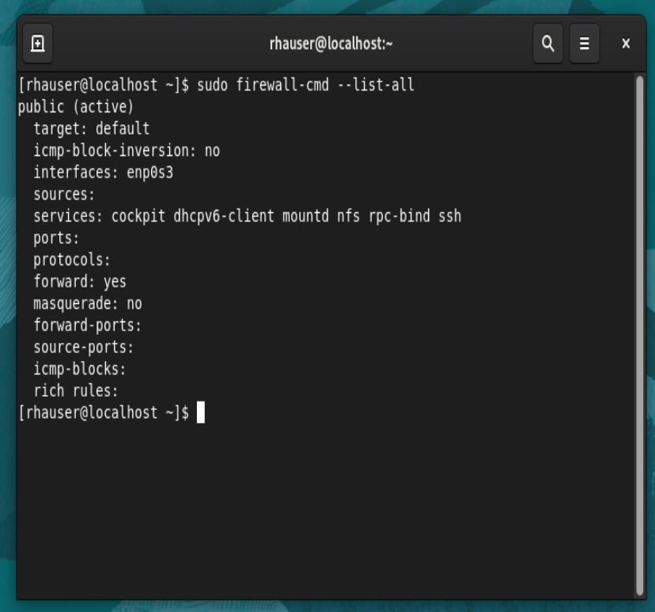

Task 4 – Configure NFS Client:
- Create a directory named /mnt/nfs-client/share
- Mount the NFS Server directory /mnt/nfs-server/share to the /mnt/nfs-client/share directory. Ensure the mount will persist after reboot. Make sure you can see the Server’s NFS share folder from the client.
- Create a symbolic link to the share from the rhauser home directory, name this link nfs-share.
- On your NFS Client, run the following command:
sudo ls -l ~
sudo tree /mnt
sudo ls –lR /mnt
Take a screenshot of the terminal output and paste it here:

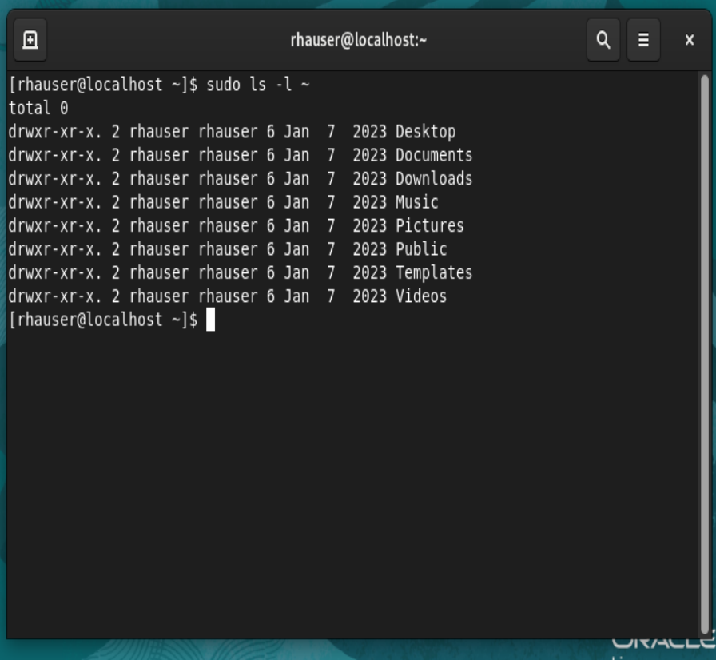
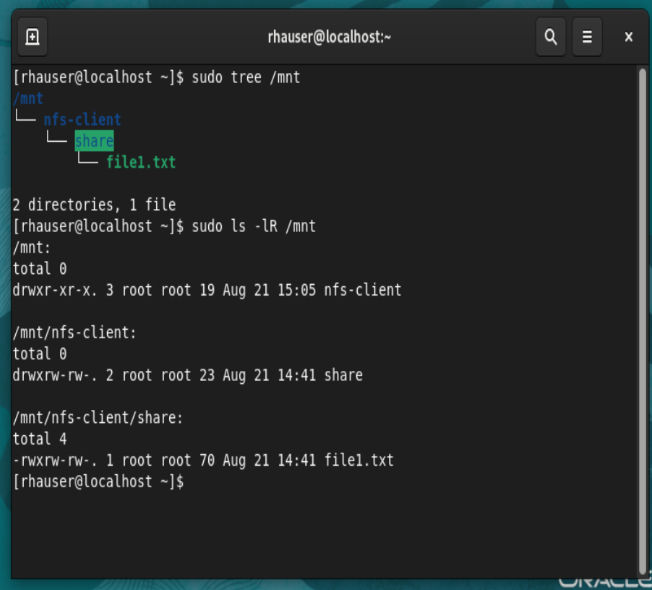
q

- On your NFS Client, run the following command:
sudo df -h
sudo cat /etc/fstab
Take a screenshot of the terminal output and paste it here:

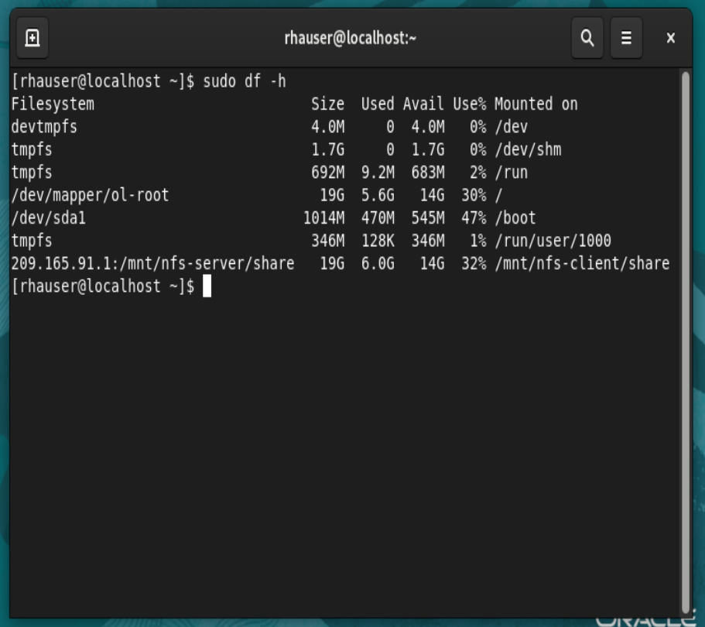

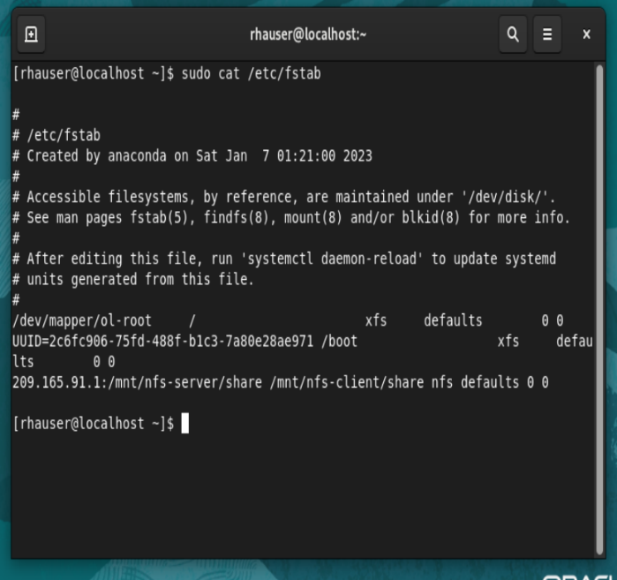

Task 5 – Test the NSF Share:
- From your user home directory, using the symbolic link, open file1.txt on the NFS shared folder and add some more content. Save this file.
- Create a new file named file2.txt and add some content. From your NFS Server verify the changes made to the shared folder.
On your NFS Client, display the contents of both file1.txt and file2.txt. Take screenshots of the terminal output and paste it here:
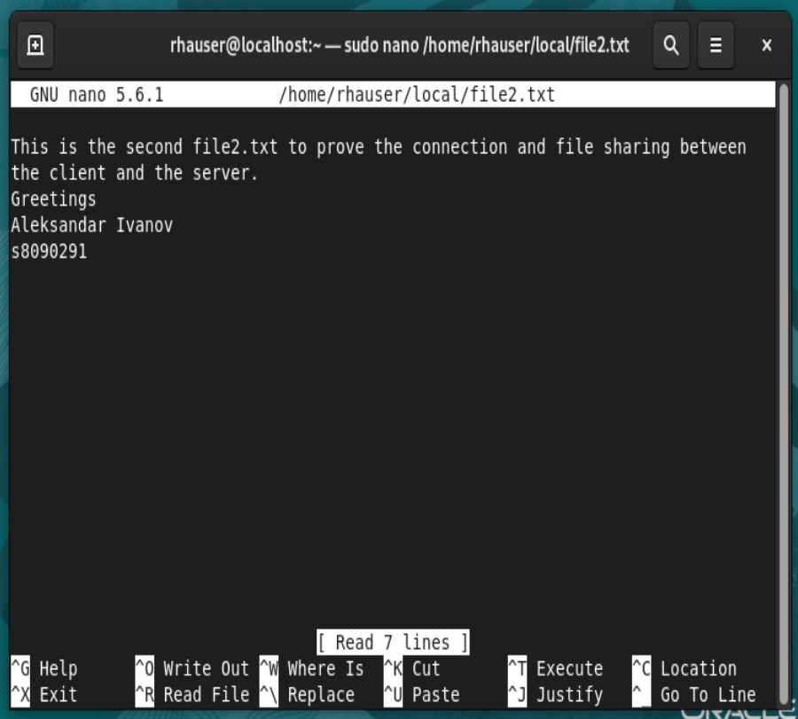
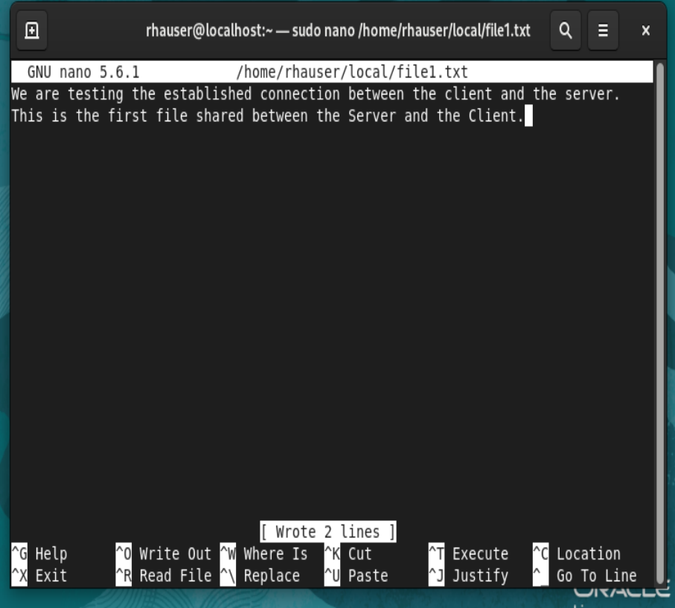

On your NFS Server, navigate to the NFS share folder, display the contents of both file1.txt and file2.txt. Take screenshots of the terminal output and paste it here:
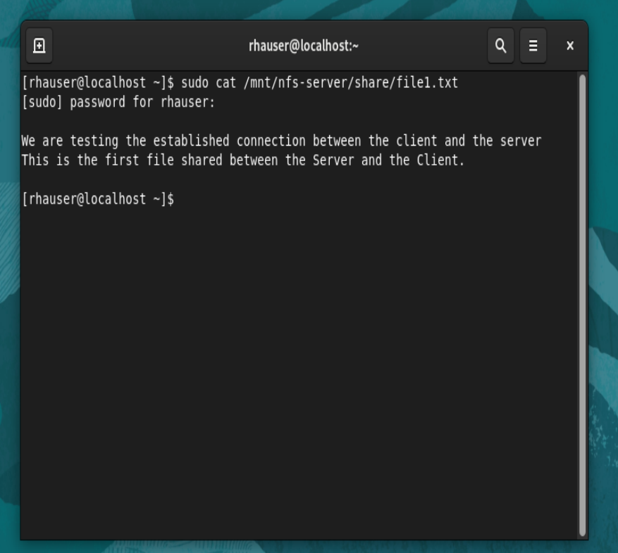

Extra Space for additional Screen Captures:

END OF PRACTICAL ASSIGNMENT ASSESSMENT

RUBRICS

Assessment Criteria | Possible Marks
Task 1 - Virtual Machine Installation
Install Virtual Machines (Server, Client) on internal Network | 1
Install required packages on Virtual Machines | 1
Task 2 - Peer to Peer Networking
Configure IP settings on NFS Server | 1
Configure IP settings on NFS Client | 1
Server and Client machines can ping each other. Network connectivity verified. | 1
Task 3 – Configure NFS Server
NFS Server service is started and active | 1
Firewall is configured correctly to permanently allow inbound traffic for NFS, RPC-BIND and MOUNTD Services. Firewall settings must be enforced. | 1
NFS Share directory created as per specification and sample files created | 1
Correct Permissions set on NFS Share directory and files | 1
Correct NFS entry in exports file | 1
NFS Share exported successfully. | 1
Evidence NFS share is working correctly on NFS Server | 1
Task 4 – Configure NFS Client:
NFS Share directory for local mount created as per specification | 1
NFS Share is mounted successfully. | 1
Evidence NFS share folder and contents can be seen from NFS Client local mount. | 1
NFS Share will persist over reboots (permanent). | 1
Symbolic link to the local share from user’s home directory. | 1
Evidence NFS share is working correctly on NFS Client. | 1
Task 5 – Test the NSF Share
Creation of new files or editing existing files in the NFS Share is visible from both machines. | 2
Total Marks | /20
Total Weight | /20

